**Assignment No:-9**

Name:-Suryawanshi Sangramsingh Sambhaji

Batch: - Delta - DCA (Java) 2024 Date:-11/5/2024

**1. Write a Java program to find the sum of digits of numbers from 100 to 200 using nested loops (all three loop).**

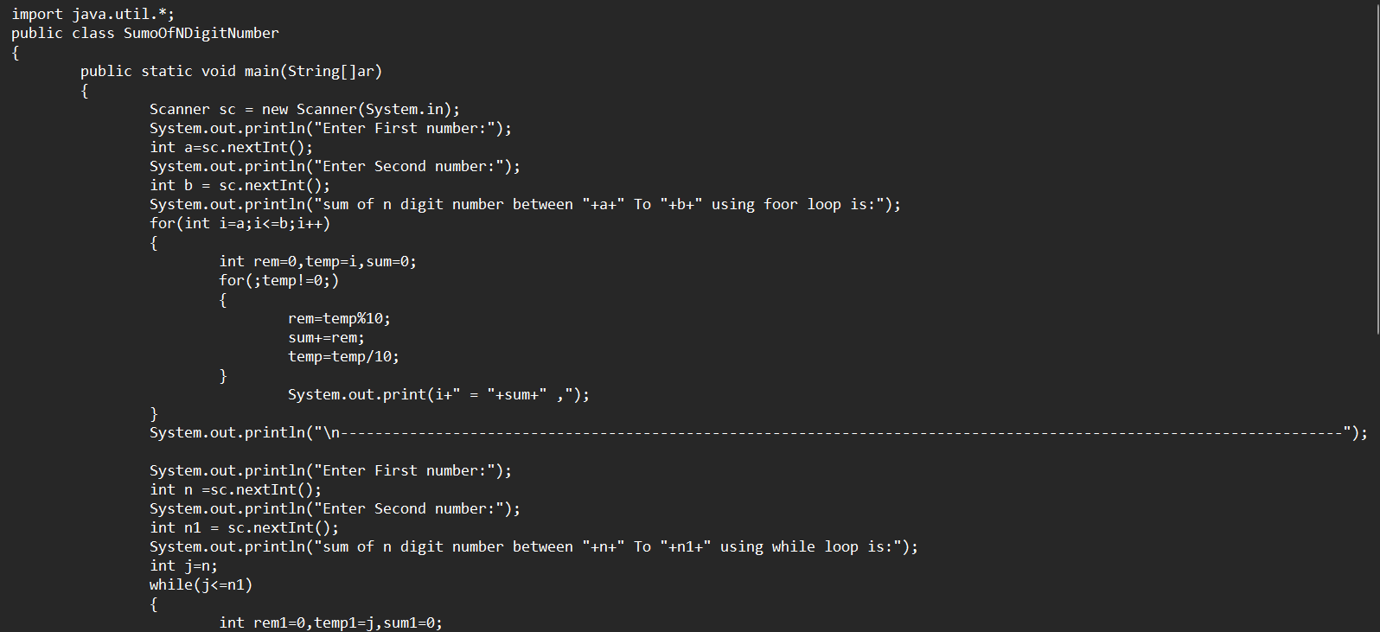 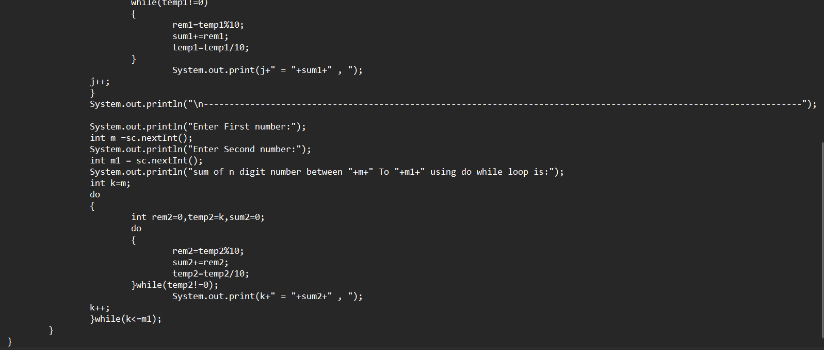

**Output:**

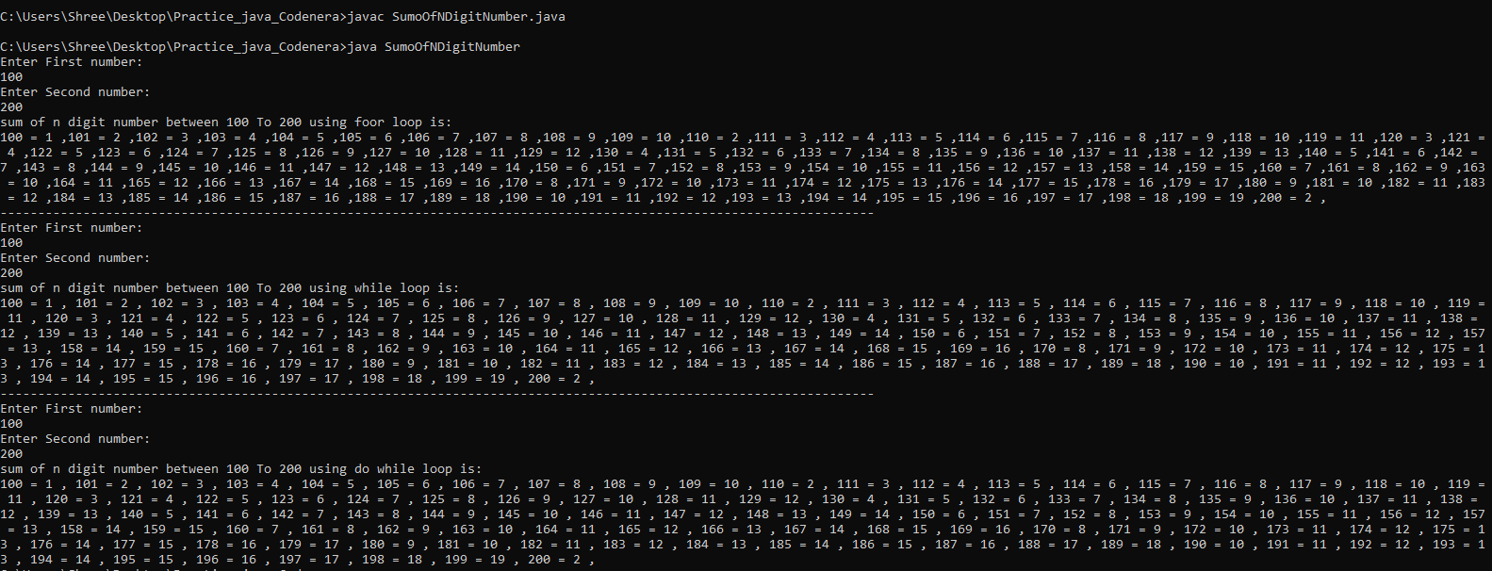

**2. Develop a Java program to generate the Fibonacci series up to a given limit using all three loop.**

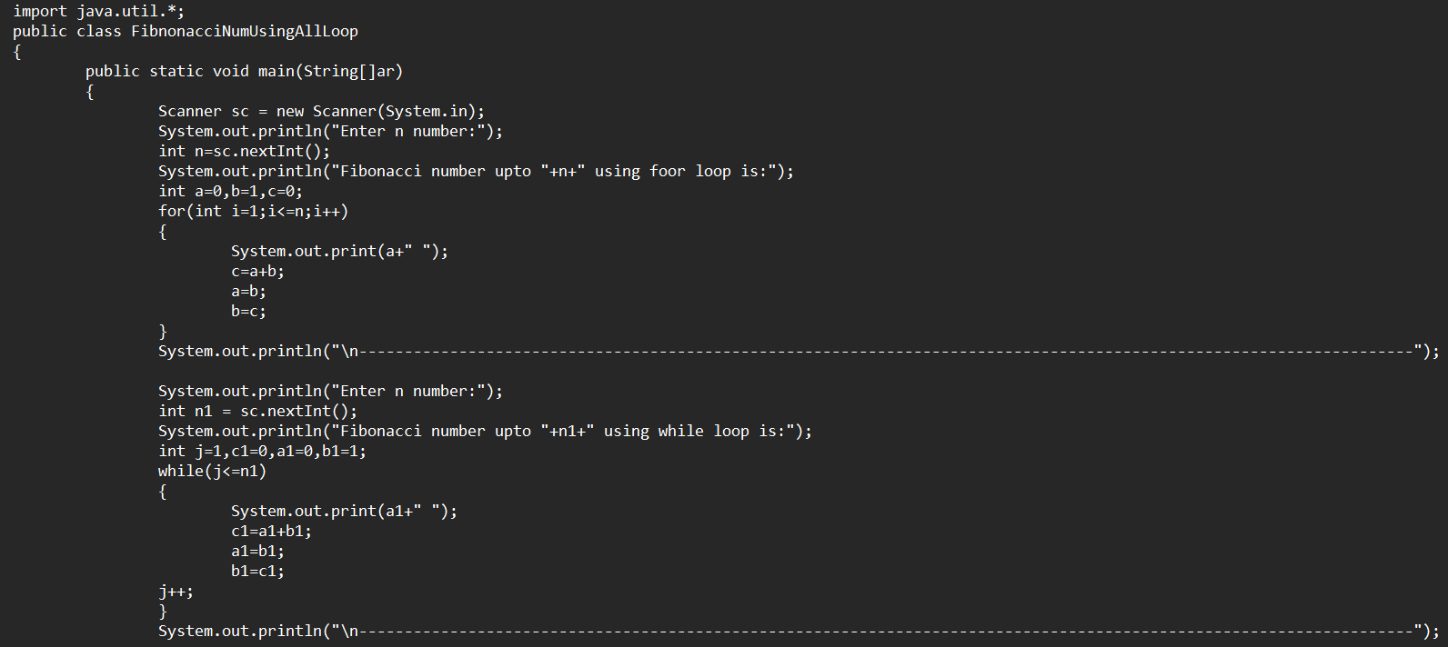 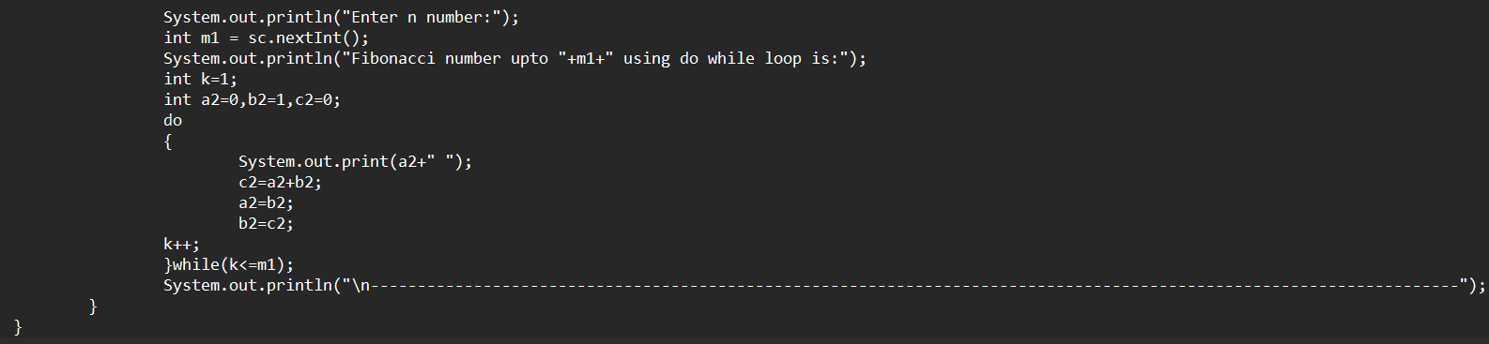

**Output:**

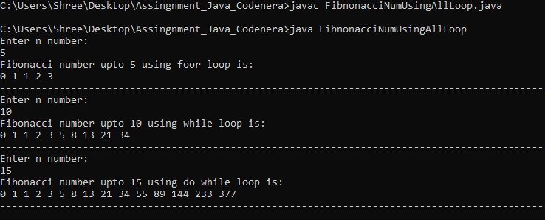

**3.** **Write a Java program to print the multiplication table of numbers from 1 to 10 using nested loops. (All three loop).**

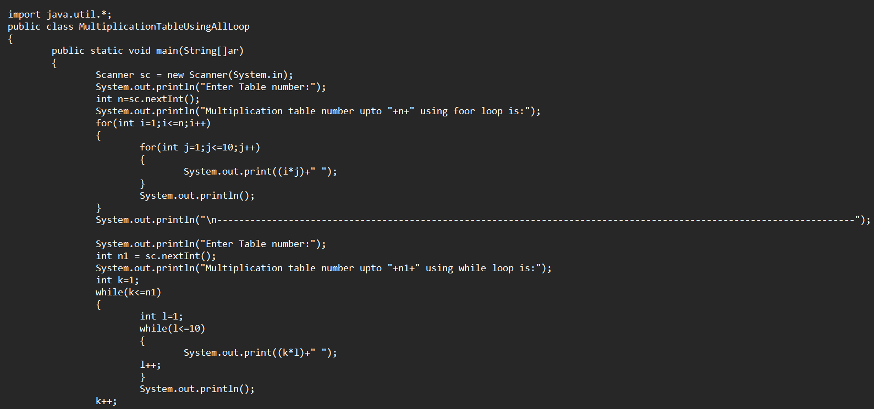 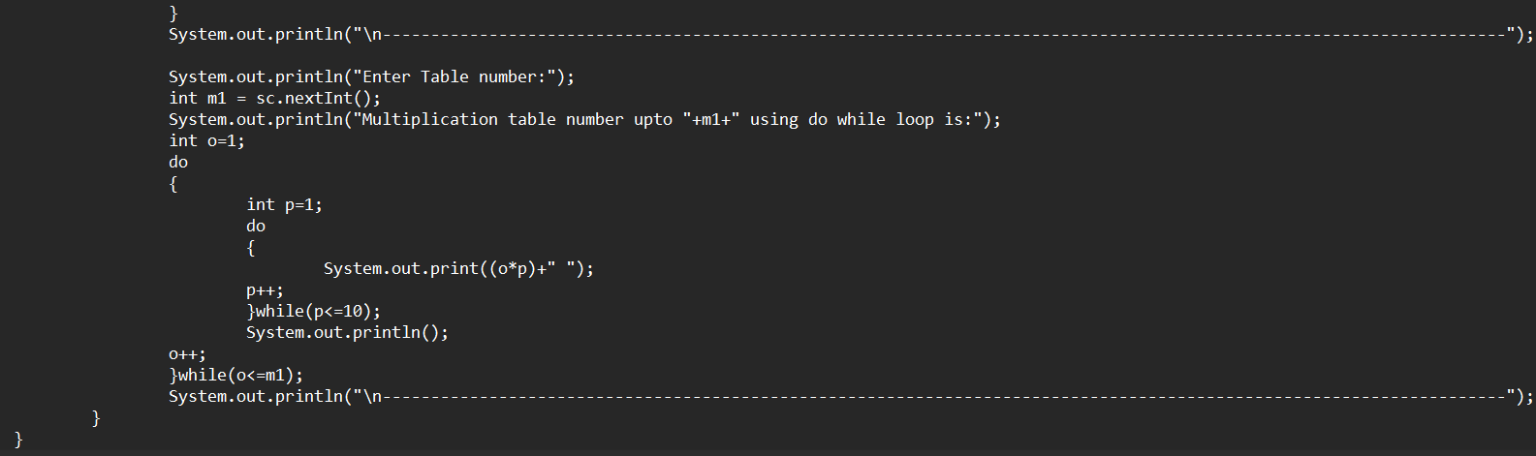

**Output:**

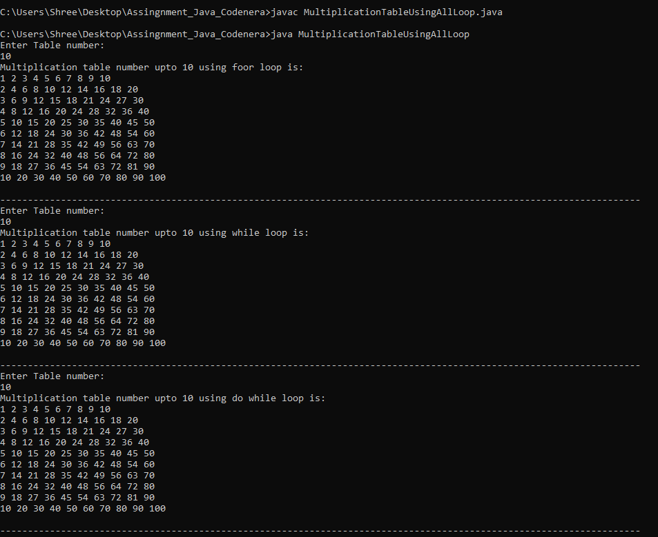

**4.**  **Implement a Java program to find the factorial of numbers from 1 to 10 using nested loops. (All three loop).**

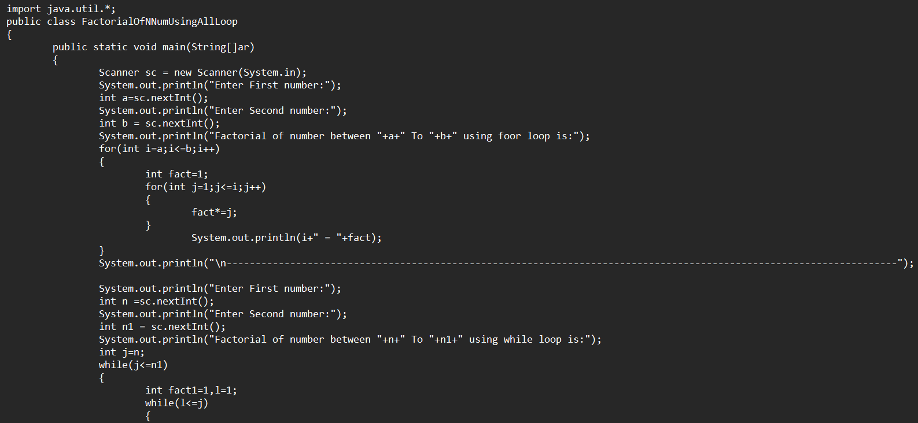 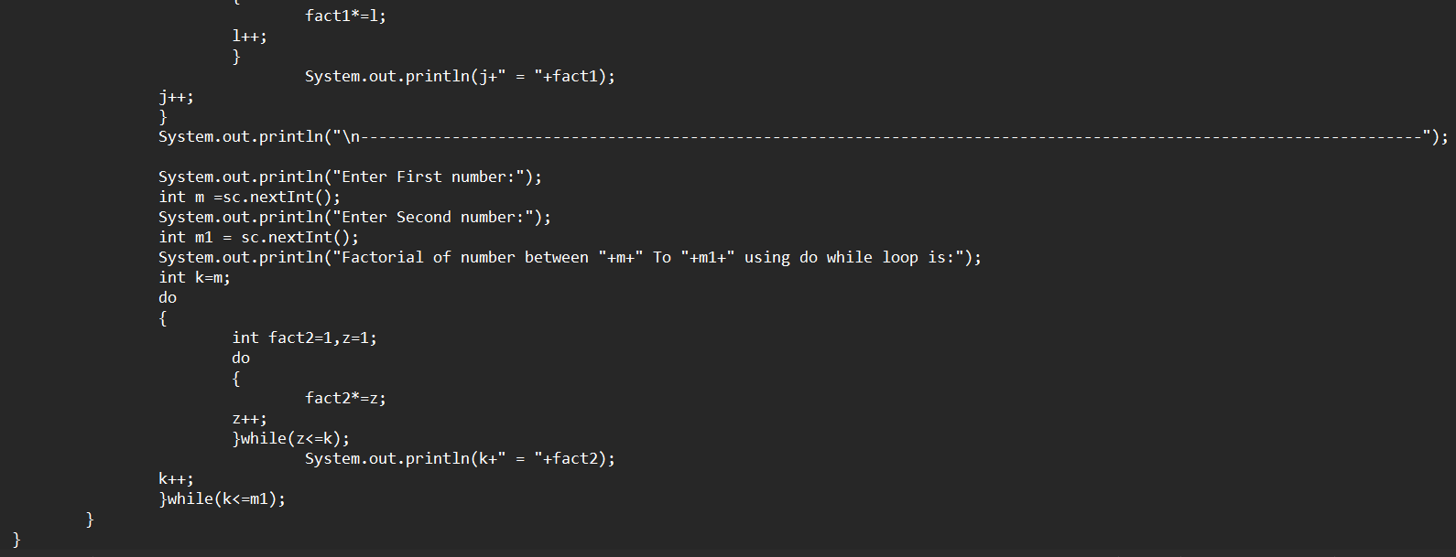

**Output:**

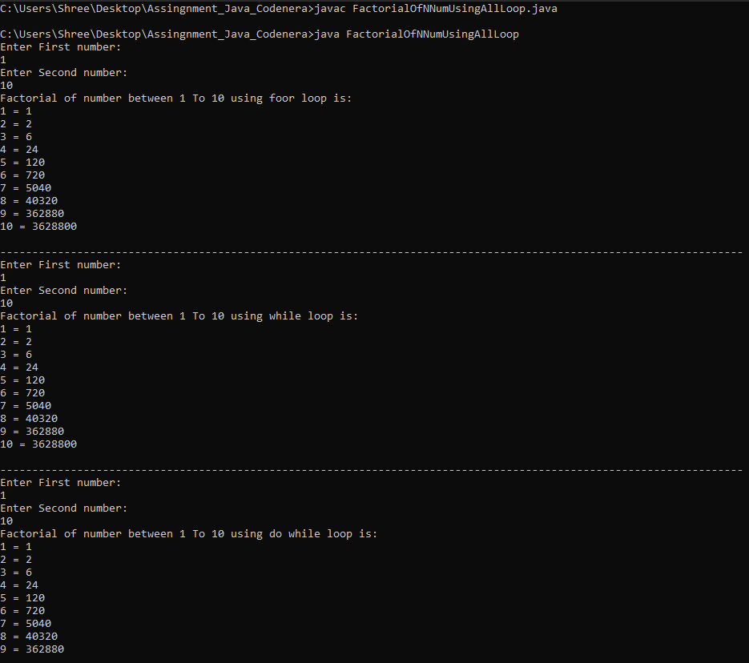

**5.** **Develop a Java program to find all Armstrong numbers in a given range using nested loops. (All three loop)** 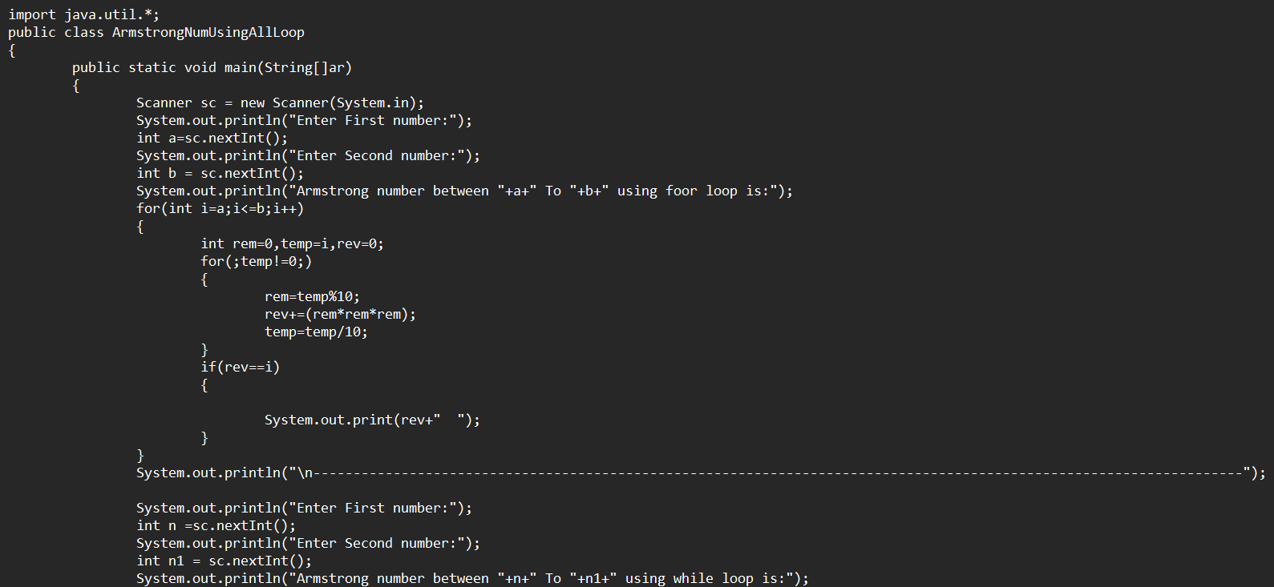 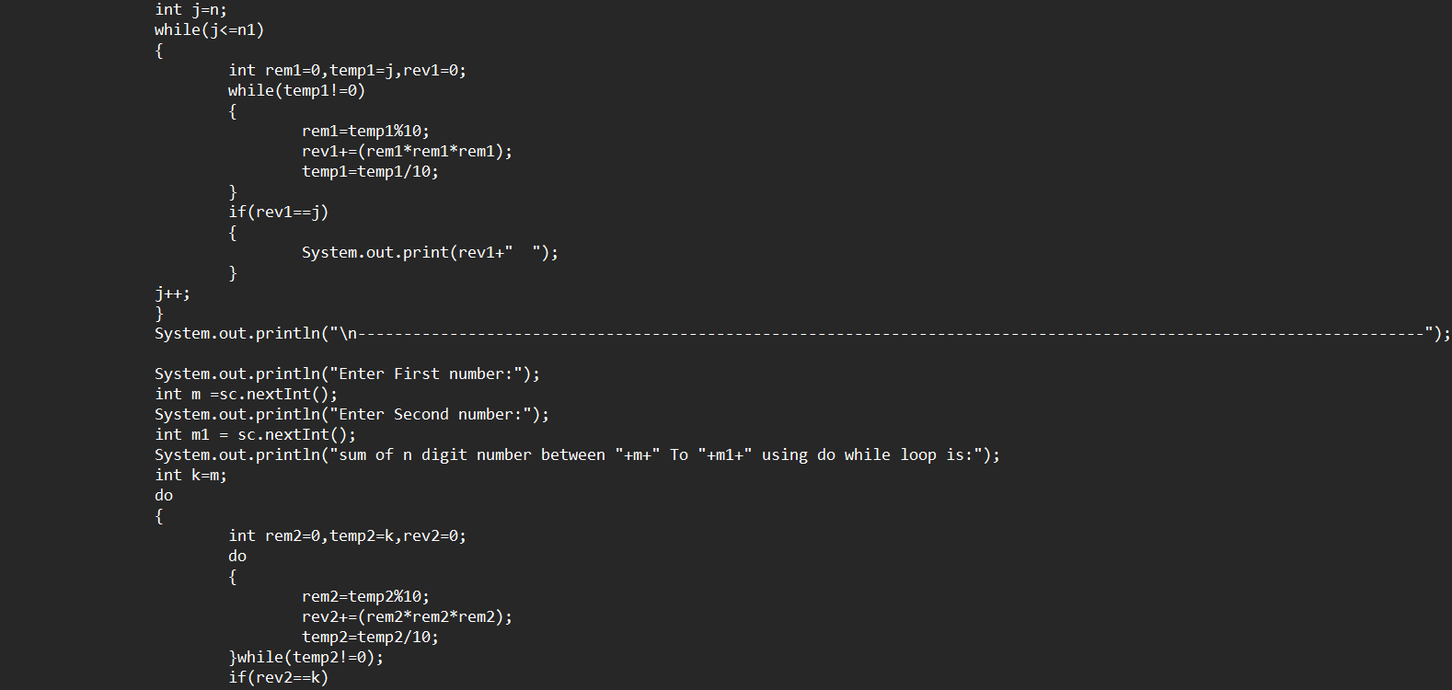 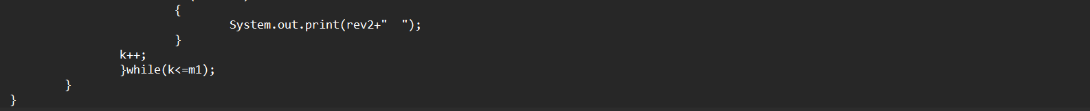

**Output:**

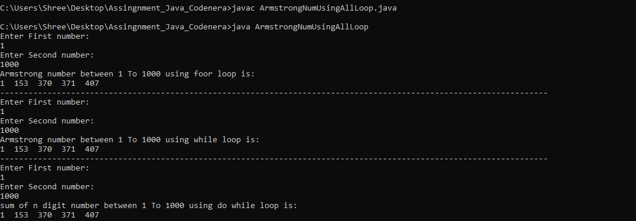

**6.** **Write a java program take an input of n digit number from user and find the secmax digit from that number (using all loop).**

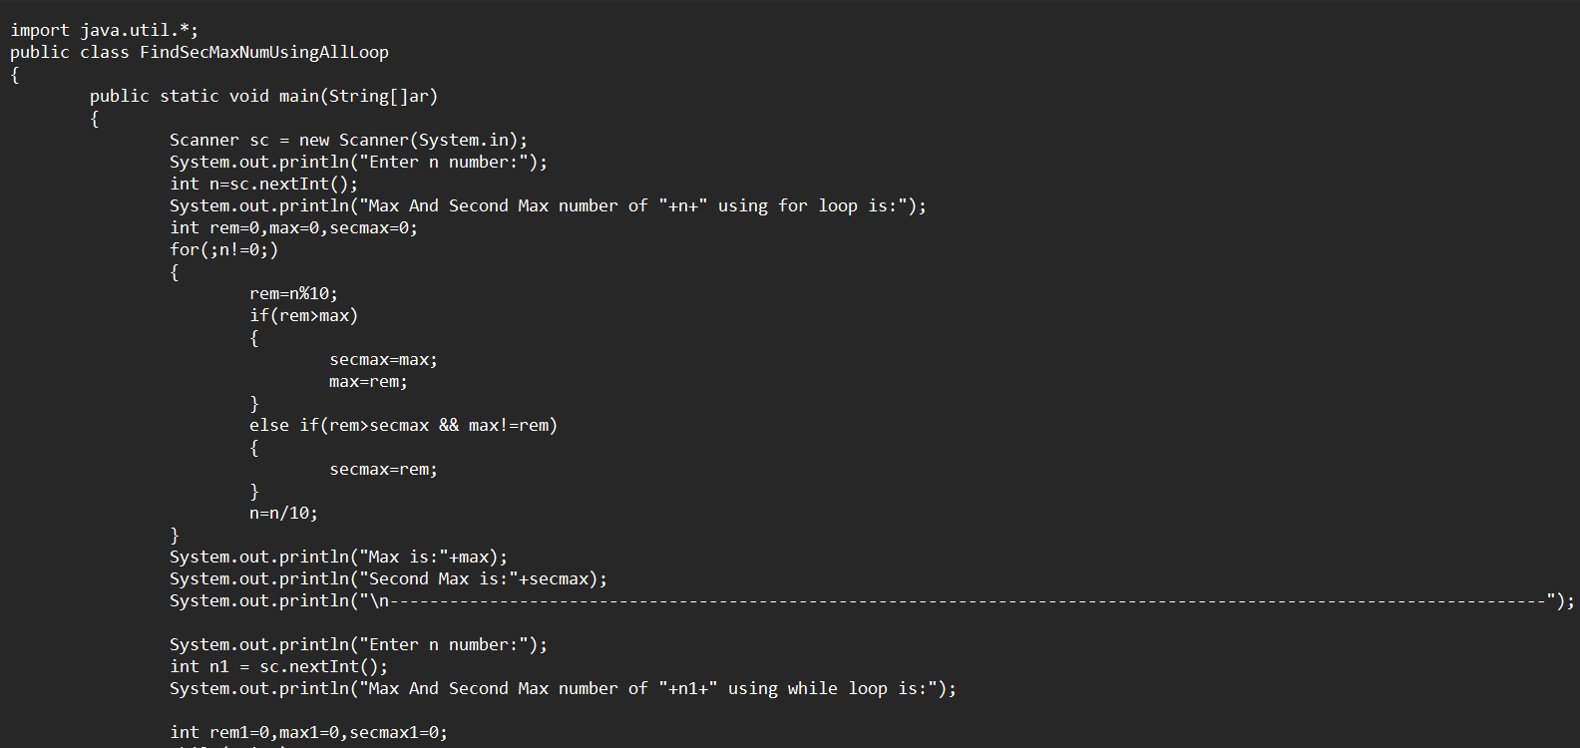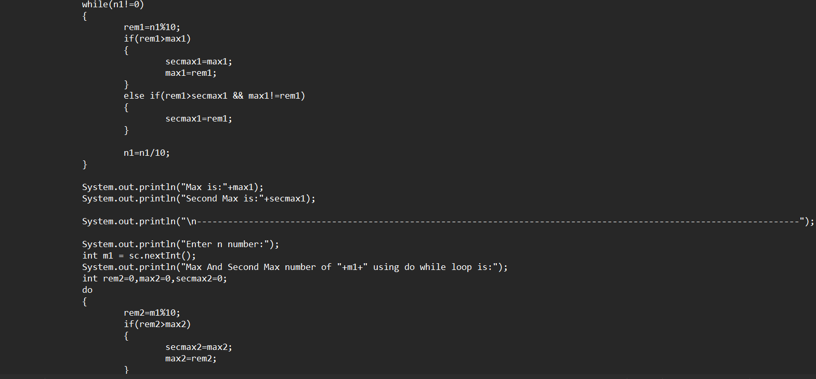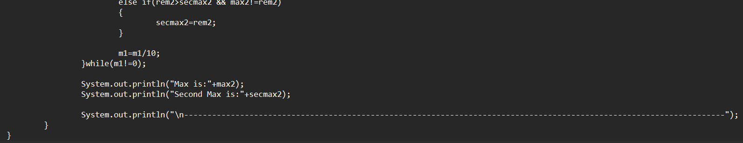

**Output:**

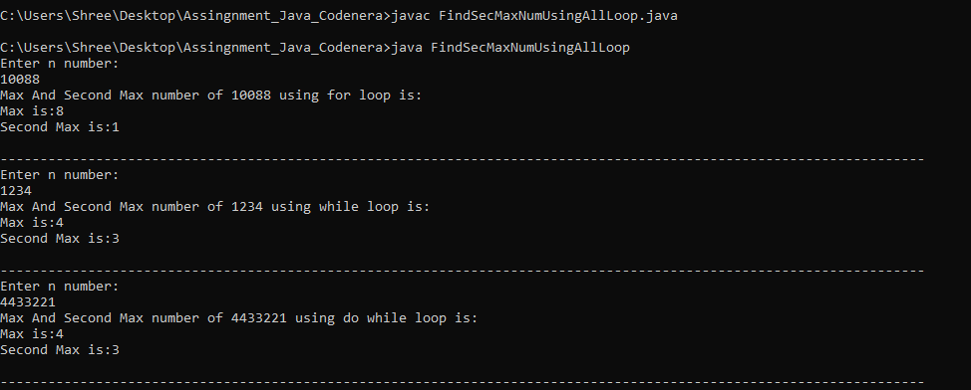

**7. Create a Java program to generate all prime numbers between 1 to 100 using nested loops.**

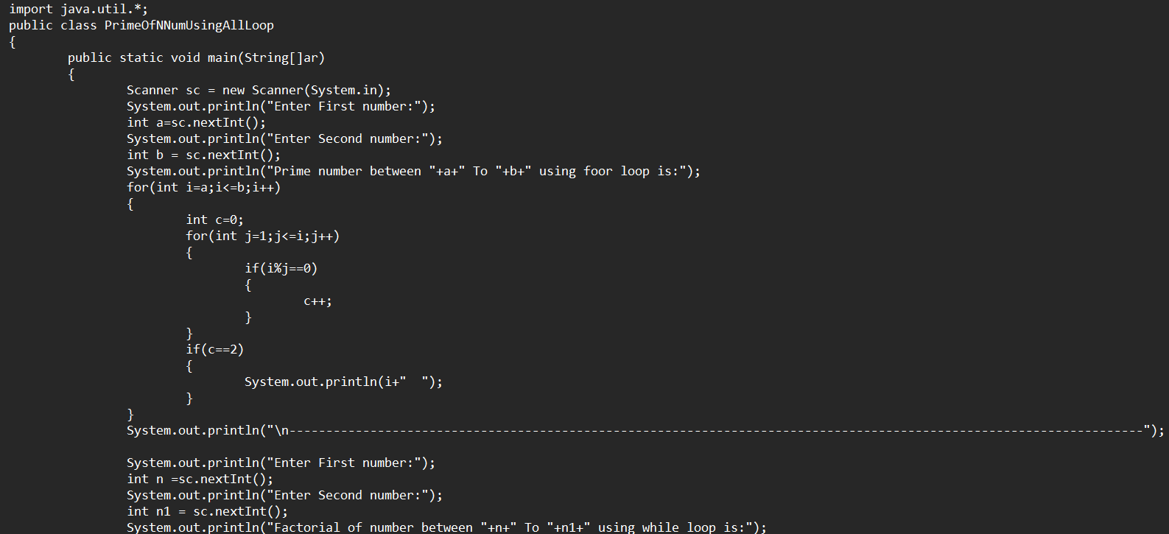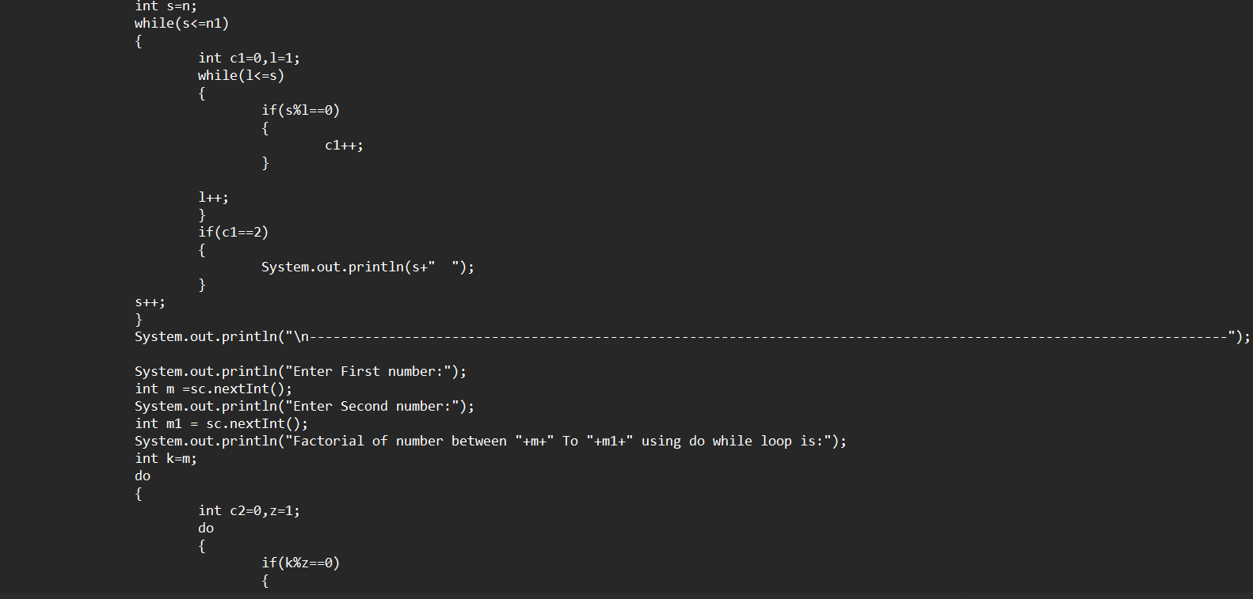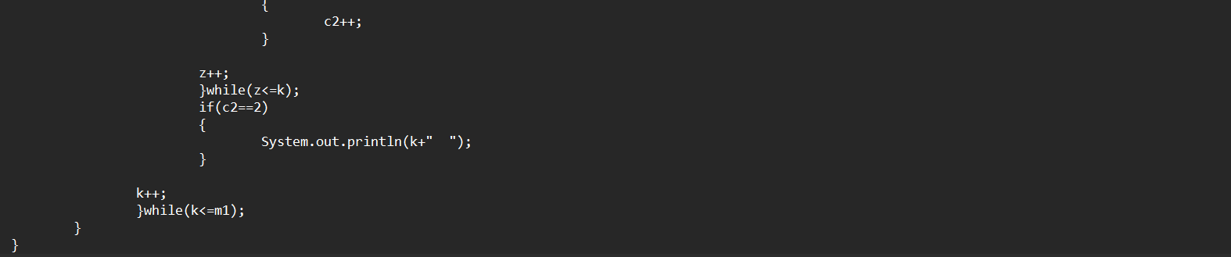

**Output:**

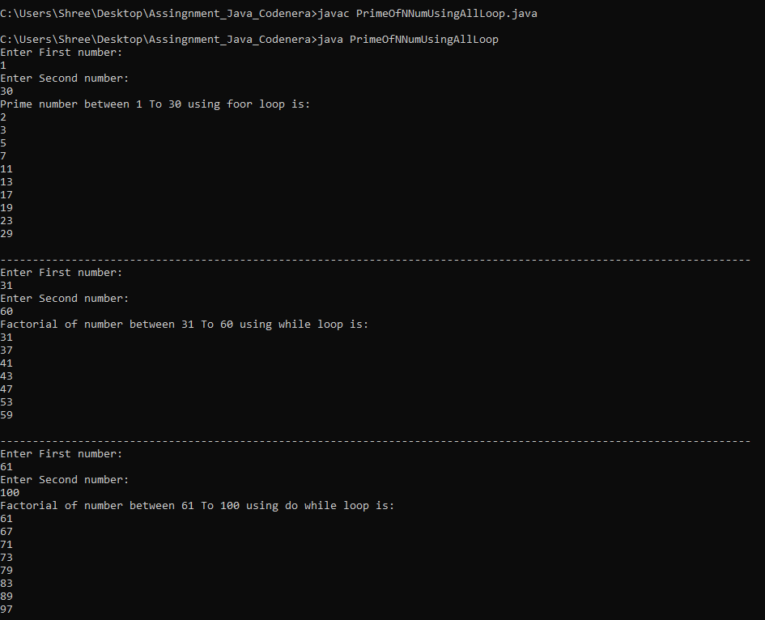

**8. Implement a Java program to print all factors of numbers from 1 to 100 using nested loops.**

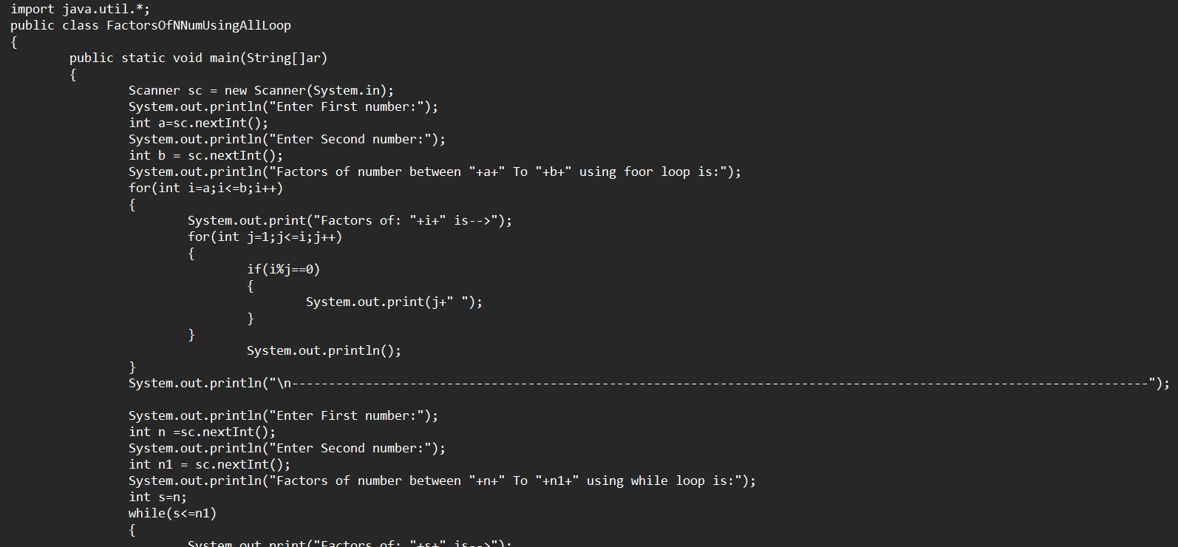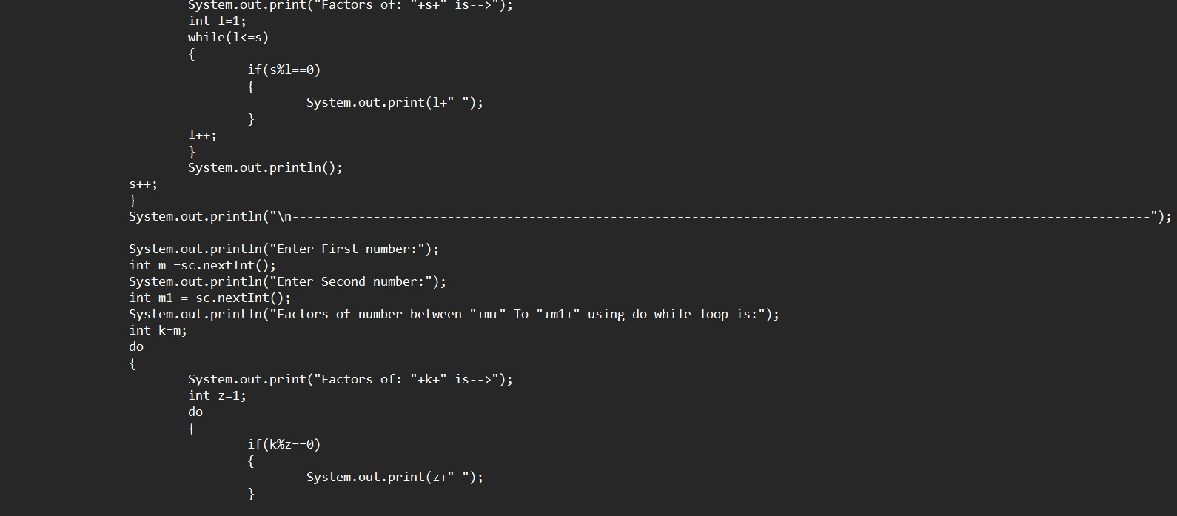

**Output:**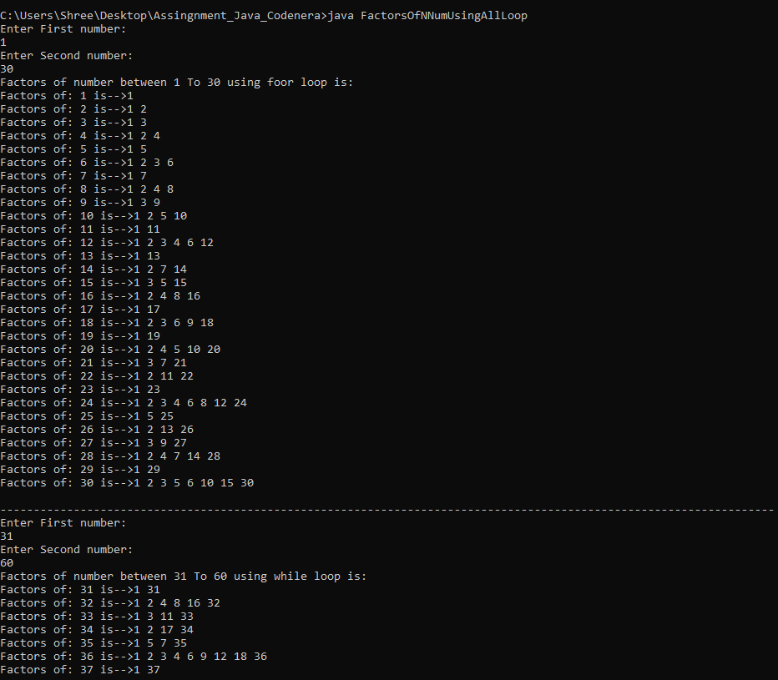 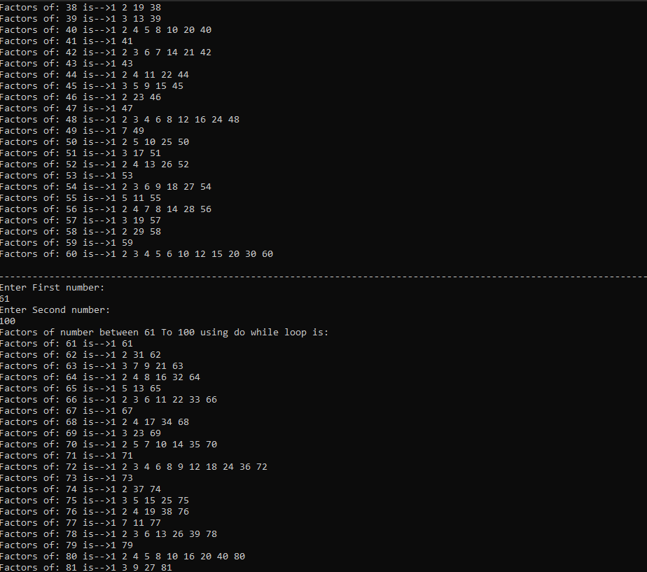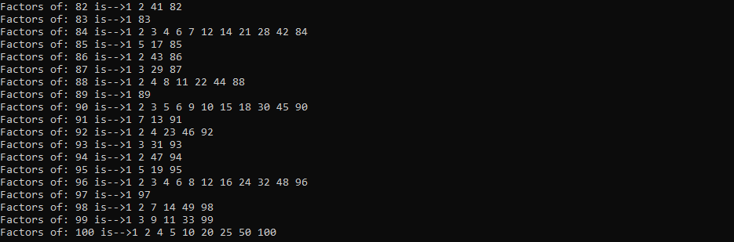

**9. Write a Java program to calculate the sum of the series 1 + 1/2 + 1/3 + ... + 1/n using nested loops.**

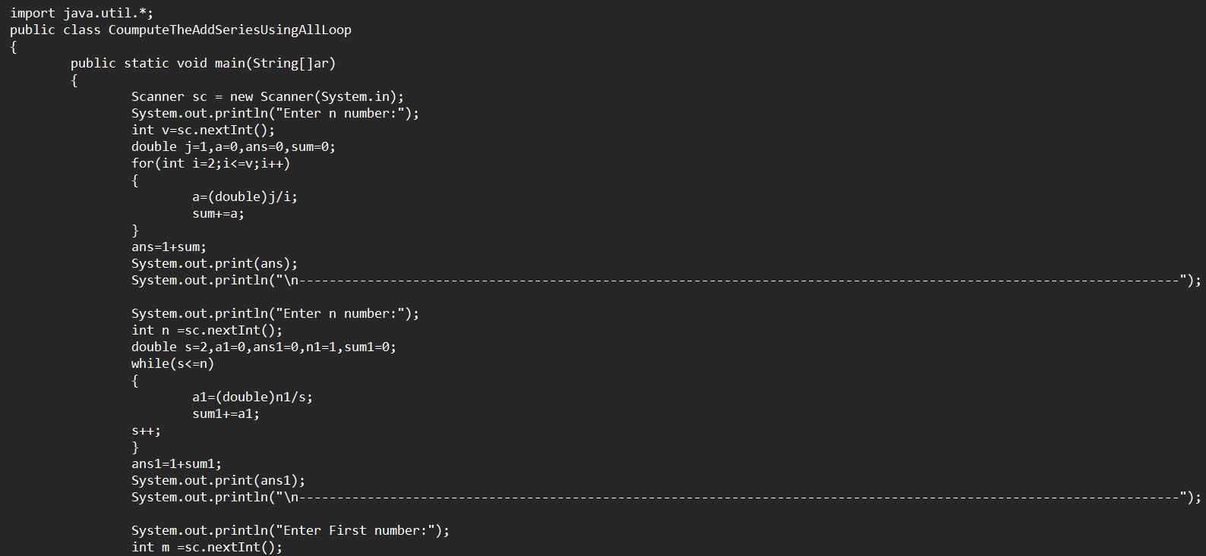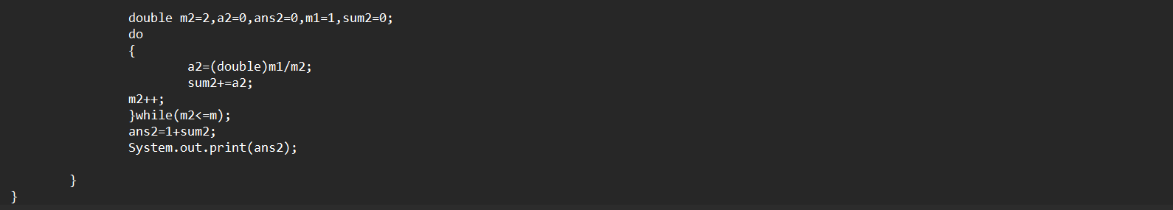

**Output:**

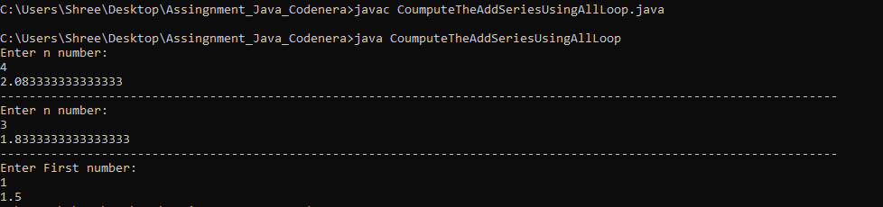

**10. Write a java program take an input of n digit number from user and find the secmin digit from that number (using all loop)**

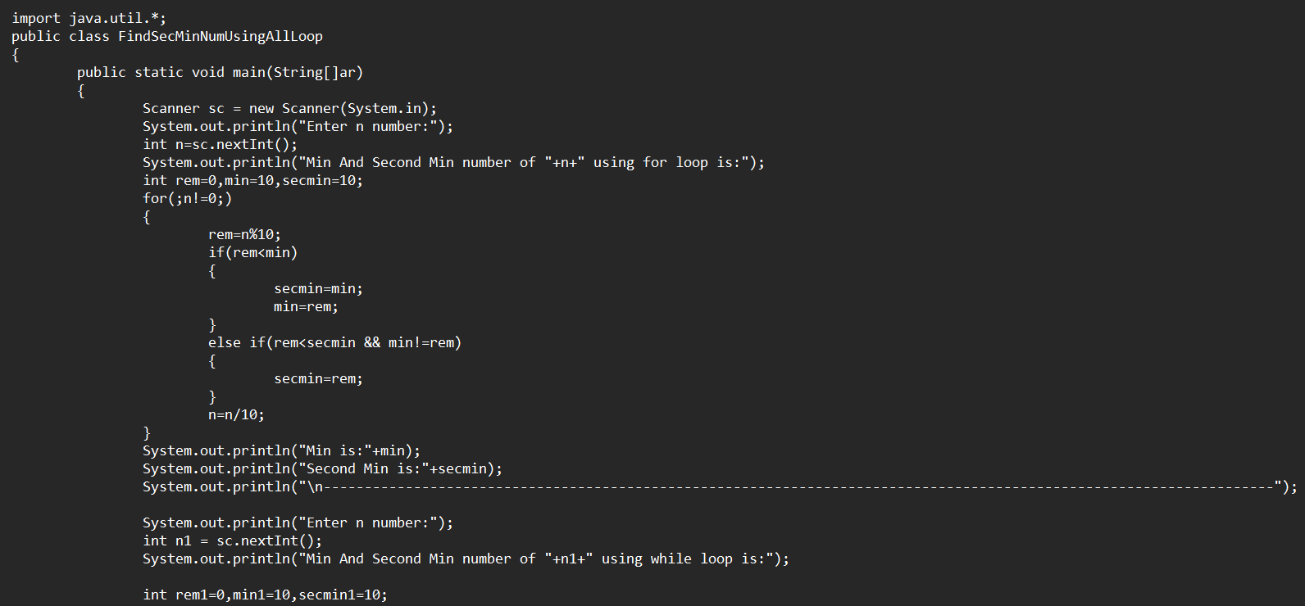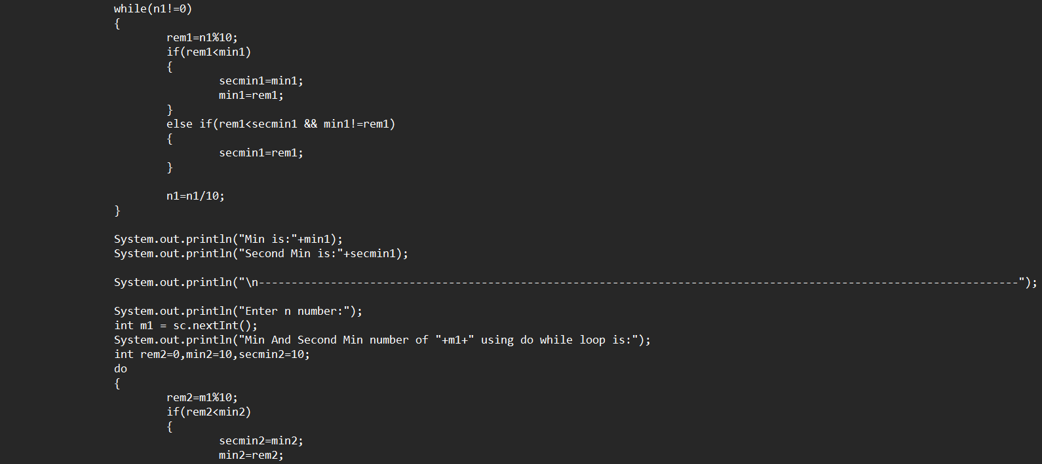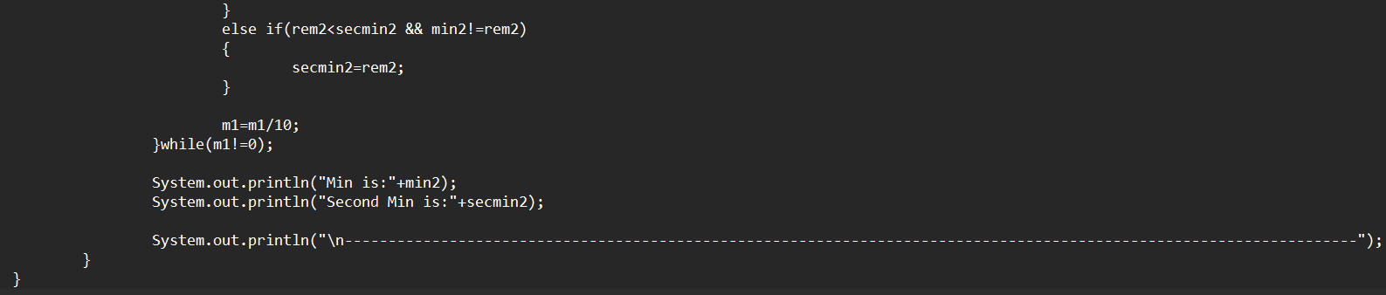

**Output:**

